Novex Compund Microscope

Objective Magnification: x4 0.1 / x10 0.25 / x40 0.65 / x100 1.25 (oil)

Screw for eyepiece turret
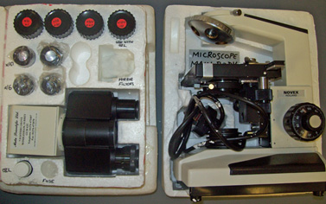
Objectives
Eyepiece lenses
Objective
Ring

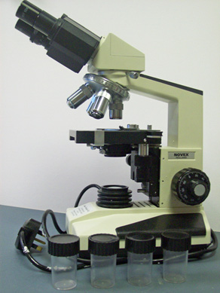
Eyepiece turret
Fine and Coarse Focus

In Box: Slot eyepieces (x10 or x16) into eyepiece sockets and screw eyepiece holder onto main body of microscope. Then screw objective lenses into silver objective ring.

Out of Box: your microscope is ready to use to view specimens by lighting specimens from below. If using the x100 lense, you will need to use oil between the lense and the top of the cover slip.

